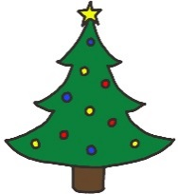
As part of our Christmas fayre (Friday 2nd December 3:15pm – 5:15pm) Year 3 and 4 with the School Council have organised a competition to raise money for our nominated charity, SARA.
There will be a competition taking place called The Christmas Bake Off! The theme of the Christmas Bake Off will be ‘Winter Wonderland’ and it will cost £1 to enter (all proceeds will go to SARA).
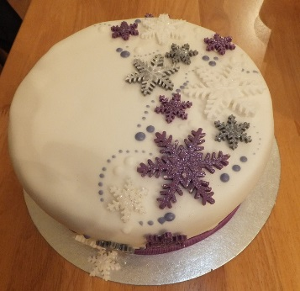
If you would like to enter our competition, please bring your baked goods to the Year 4 classroom before School on Friday 2nd December.
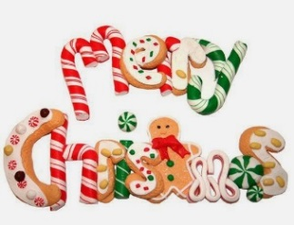
The results of The Christmas Bake Off will be announced during the evening of the Christmas Fayre. There will be a 1st, 2nd and 3rd place for KS1 and a 1st, 2nd and 3rd place for KS2.
If you have any questions, please ask Year 3 or 4 School Council reps.

