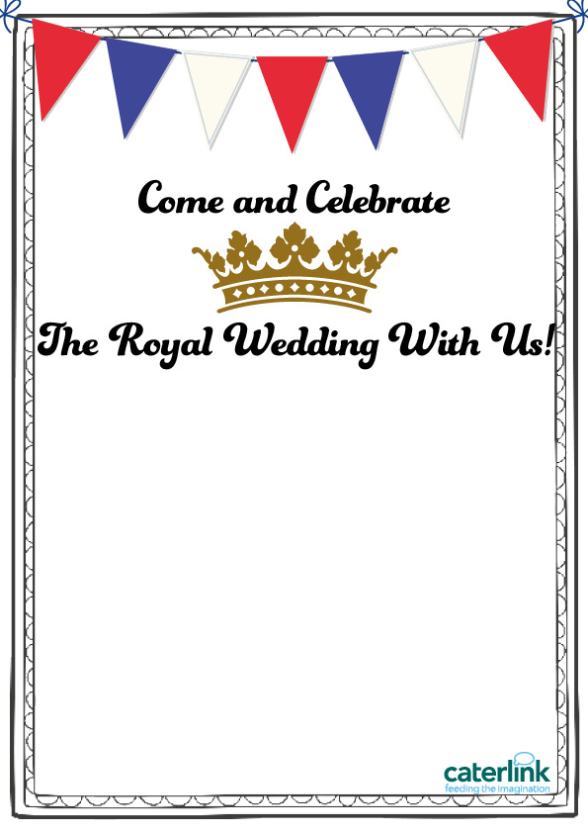

**Monday 14 May 2018**

MAIN

Princely Pizza (Chicken, cheese, pineapple)

VEGETARIAN

Princess Pasta (Macaroni Cheese)

SIDE

Windsor Wedges (Baked potato wedges)

VEGETABLES

Summer Salad (Mixed leaf salad)

DESSERT

Congratulation Crumble (Pear)