Tutshill C of E Primary School

Induction pack

2017/2018

For volunteers, Governors and new members of staff

You will be asked to sign to say that you have received this induction pack. As part of the induction it is expected that you will read all of the relevant policies.
Guidelines for new staff, governors and volunteers
As a new member of staff, governor or volunteer you may be in regular contact with children and in an excellent position to get to know them well. You will be able to develop trusting relationships, observe changes in behaviour and sometimes may be chosen to share a young person’s confidences or concerns.
We rely on all those working with children to take any suspicions, allegations or concerns about a child seriously.
If a child tells you that they are being abused: (refer to Child Protection policy for definitions of abuse)
- Allow them to speak without interruption and accept what they say. Never add personal opinion when reporting.
- Never agree to keep information confidential.
- Tell them that you must hand the information to the designated safeguarding lead teacher or their deputy. (Mrs N Fryer/ Miss J Lane).
If you receive an allegation involving a member of staff, carer or volunteer:
- Inform the Head Teacher or Senior Teacher immediately.
- If it is the Head Teacher or Teacher, inform the Chair of Governors.
- Do not discuss the matter with anyone else.
- Record what you have been told and give the record to the Head, Manager or Chair of Governors as appropriate.
- DSL: Natalie Fryer, Deputy DSL: J Lane, Child Protection Governor: Mrs Marilyn Henderson, Chair of Governors: C/O Mrs Marion Evans.

Gloucestershire Safeguarding Children Board helpdesk 01452 426 565

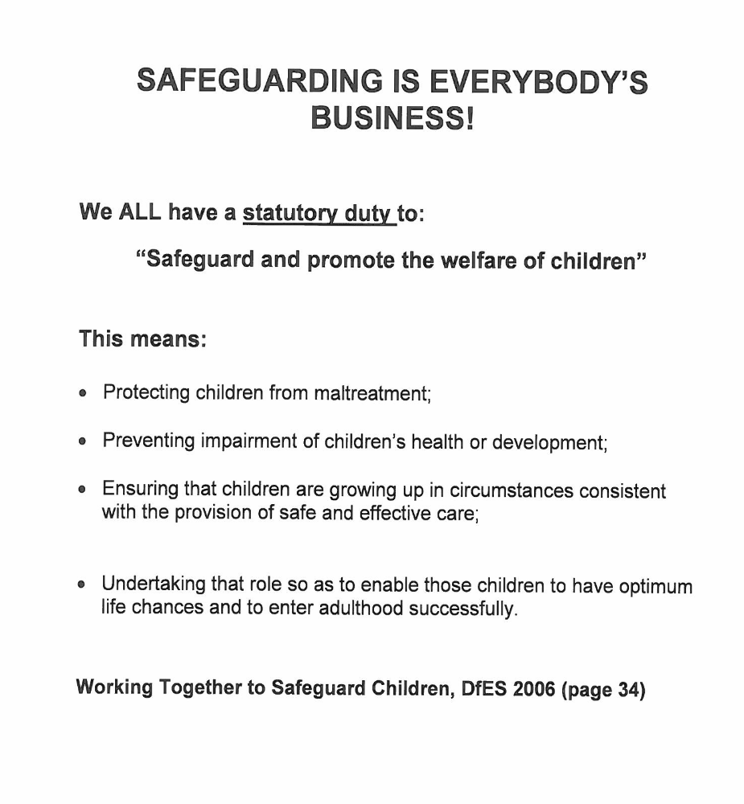

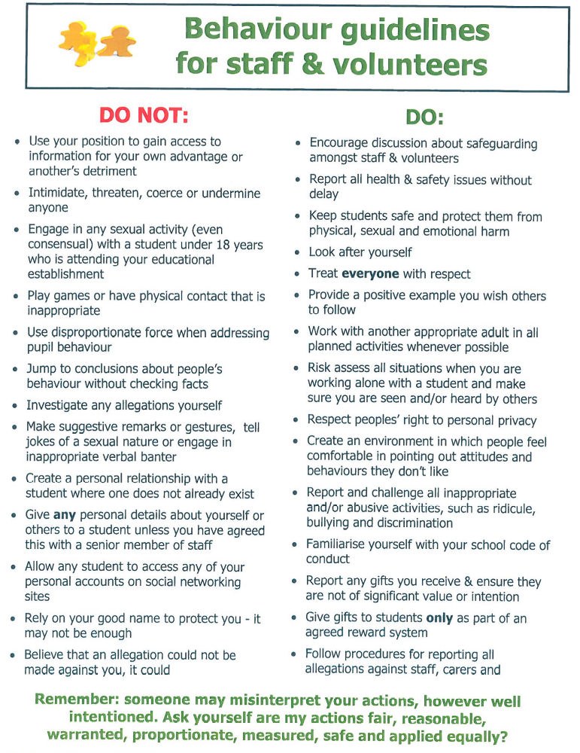

Professional has concerns
If a Professional has a concern about the well being of a child (or unborn baby), then that professional should:-
Consultation with supervisor
share their concerns with their supervisor/line manager/designated teacher or named professional to help clarify the nature of their concerns
Completion of written record
complete a written record of the nature and circumstances surrounding the concern including any previous concerns held
Contact social workers for advice
in those cases where you have a concern but are unsure about how to proceed contact the

Children’s Help Desk Tel: 01452 426 565

and ask to speak to a social work practitioner
.
Contact the children’s helpdesk
In those cases where you are clear a social work assessment is required make a referral to the:

Children’s Help Desk Tel: 01452 426 565

within 24 hours (immediately if the concerns are about physical injury or sexual abuse). The CYPD social care section will then take responsibility for managing any subsequent enquiries. The referrer should confirm the details of the concern to CYPD, in writing, within 48 hours
Resolving professional Difference (escalation policy)
Remember to use the ‘resolution of professional difficulties (escalation) procedures if you are left feeling that the response from social care has not addressed your concerns for the child. Advice about procedural issues including using the resolving professional differences procedures can be obtained through the Safeguarding Children Service on 01452 58 3629

For out of hours social work advice please contact the Emergency Duty Team on 01452 614 194

Primary | Username | GlosEdAc-Prim1z
Primary | Password | GSCBEdP920g
Access to all the E-Learning is free for staff from any organisation, user names and passwords for each individual course are detailed below. Please select according to your setting. There are separate usernames/passwords for each of the courses – you cannot use the same username/password for different courses.

To log on to a course

- Obtain Username and Password from selecting your setting below
- Ensure you work on a computer attached to a printer. You are not able to print your certificate off at a later date
- Log on to the KWANGO website at www.Kwango.com
- Type the username and password into the logon boxes
- You will be taken straight to the ‘launch page’ for your e-learning course
- Press the ‘Launch’ button and the course will begin

Welcome to Tutshill C of E Primary School

Thank you for your contribution to our school community. I hope that your time with us will be enjoyable, productive and rewarding.

This information pack has been compiled to help you with your role in school and answer some of the frequently asked questions that volunteers have. You will find here:

- School routines

- School rules and expectations

- Emergency Procedures – fire, first aid

- Child protection information and guidelines

- A selection of school policies most relevant to your work at Tutshill C of E School

A complete set of policies is always available on the school website.

If you have any further questions, please don’t hesitate to ask me or any
member of staff.

Thank you

Miss J Lane

Headteacher

Expectations for Adults in School

Adults are expected to:

- be polite to the children and to each other
- listen to each child’s point of view
- give clear instructions
- be positive and recognise good behaviour by giving Examples e.g. – That was kind because........I liked it when you ............ because............
- be positive and recognise achievement and effort
- comment on behaviour only – That........................is unacceptable because.......
- reinforce appropriate behaviour of any child you witness
- respond appropriately when addressed by name by a child
- model appropriate movement and door courtesy
- stay calm
- Don’t allow yourself to be put in a compromising position and remember that confidentiality is essential.

School Routines

- Please sign into and out of the office.
- The bell is rung at 08:55 and at 9.00 electronic registers and dinner registers are taken.
- Assembly times Mon-Thur KS1 10:15-10:30a.m.
Fri whole school church 09:15a.m..
- Playtimes 10:30-10:45 a.m
If it is wet children stay in their classrooms supervised by teachers.
- Lunch break KS212:00-13:00. KS112.15 -1.15
- Electronic registers are taken when the children return to the classes after lunch.
- School day ends at 3:15pm when all children are escorted into the playground. Children in Key stage 1 are handed over to their parent one at a time. Children in key stage 2 go onto the playground together and teachers remain with them until they are collected by the parents. If parents don’t arrive children stay with their teacher. Children in year 5 and 6 are allowed to walk home alone on receipt of a written request from parents.
- We expect good behaviour at all times. If there is a problem please speak to the class teacher.

Fire Procedures
Fire procedures and exit routes are on display in all classrooms. Please assemble in the playground where your name will be checked against the visitors book by a member of office staff.
Do not return to school until told to do so by the Head Teacher or Fire Officer.

First Aid
If a child is injured please seek advice from a member of staff. Mrs H Prince has overall responsibility for first aid within school, but class teachers and teaching assistants are first aid trained and will deal with minor accidents. Each classroom has an emergency first aid pack. All children who have medical issues have photographs in the medical room and displayed in classes.
Individual children’s asthma inhalers and Epi Pens are located within each classroom.

Refreshments
Coffee and tea are available in the main staff room. We ask for a voluntary contribution of 20p per cup.

Toilets
Toilets can be found at the base of the stairs near the staff room, in the corridor near the office. A disabled toilet is situated near to the library and opposite the school office.

Useful Policies

Please ensure that you read the following policies:
Policies can be found on the school website:
- Safeguarding policy
- Anti-bullying policy
- Race equality policy
- Confidentiality
- Behaviour
- Health and safety

A full set of policies is available on the school website.

I have read and understood the contents of the school policies, found on the school website, listed below.

Policy | Signature
- Safeguarding policy
- Anti-bullying policy
- Race equality policy
- Confidentiality
- Behaviour
- Health and safety
- Keeping children safe in education part 1

Please return this sheet to school.
Thank you

