Spirituality at Tutshill C of E Primary School
‘Love One Another, Know Ourselves, Believe and Grow’
1 John 4:7 ‘let us love one another, for love comes from God’.
This pictorial representation of Spiritual development at Tutshill C of E Primary School symbolises how we grow spiritually. The Roots and Foundation of our Spiritual development are supported by the teachings of the Bible, the opportunities embedded within our curriculum and our core tricks in our Trick Box programme. These help us to experience life and see every experience as an opportunity for personal growth and development. Through these spiritual experiences we can flourish together as a unique creation of God; showing our Christin values through all that we do.
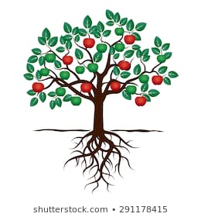
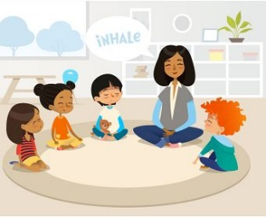
Compassion, forgiveness, respect, responsibility, compassion, courage, perseverance
The OWS
These are the moments in life where things might be difficult. They can knock the breath out of us!

The NOWS
This is the present moment. They are times when we are receptive to life and open our minds so that we can live in this present moment.
The WOWS
These are moments of awe and wonder. Times when we can breathe in the moment and capture the beauty around us.

