**OCTOBER 2019 – END OF TERM NEWSLETTER**

**Seesaw**

Following our trial period of Seesaw in Autumn Term 1, we are pleased to launch the platform as an ongoing feature at Tutshill C of E Primary School.

As part of our commitment to enhancing children’s learning, parents will be able to see what their children completed in class. The system is robust and the class page is checked frequently by the class teacher. It is important to note all comments go through a rigorous check before being approved and going live on the class page.

The school has received many positive comments from parents regarding Seesaw and we look forward to building on these.

Should you have any questions regarding the software, please do not hesitate to make contact with the school office.

**Chepstow District Rotary Club**

We would like to thank the Chepstow & District Rotary Club for their 50% donation towards the cost of the recent visit by the Life Education Inflatable Classroom. We are very grateful to receive this support from our local community.

**European Day of Languages**

Our European Day of Languages, held on Monday 30 September, was enjoyed by staff and children alike. This year, we had a focus on Welsh and Wales and everyone looked fantastic in their red, white and green clothes! The children took part in a wide range of activities throughout the day with a cross curricular approach. We would particularly like to thank Mrs Gwynne and Mrs Field who helped to organise and run Welsh language sessions, during which the children learnt Welsh language from native Welsh speakers.

Mrs Field organised for Joshua Wheeler, a Community Development Officer for Monmouthshire, to run some Welsh language sessions in school. If anyone is interested in developing their Welsh, Mr Wheeler wanted to let people know that there is an informal session that runs on a Wednesday from 10-11a.m. in Tŷ Croeso in Chepstow (the old laundrette on Moor Street). Everyone is welcome.

**Year 3 and Year 4 Trip to National Roman Legion Museum, Caerleon**

Year 3 and 4 went to Caerleon to look at the Roman ruins. We took part in recreating what entertainment was like in the Amphitheatre and took turns in reconstructing the different fight scenes. We were able to imagine how it must have felt for the slaves, prisoners, gladiators and animals whilst looking up to where 6,000 people would have spectated.

We also investigated the Roman Bath which is now inside a modern covered building. We explored the remains of the once open-air swimming pool that held more than 80,000 gallons of water. Year 3 and 4 had a wonderful time learning lots of information about the Romans.

**Harvest Festival**

Our Harvest Festival took place in St Luke’s Church on Friday 11 October. We would like to thank you for all your very kind donations that were brought to school for Chepstow Foodbank. The Foodbank were absolutely delighted with the donations received.

**Outdoor Learning Week**

Last week, we were all actively involved in our ‘Outdoor Learning Week’ which allowed us all to get outside and get muddy! We had a great time taking part in lots of practical lessons which varied from completing algebraic calculations using natural objects to writing poetry about trees! We learned about the work of Andy Goldsworthy, who is an artist/sculptor that works with natural materials, and created some amazing natural sculptures of our own. We learned how to tie knots with the help of Mr Gair and then created some fantastic frames using sticks and other natural materials. We ended the week by taking part in Gloucestershire’s ‘Big Day Daily Mile’.  This ‘Outdoor Learning Week’ was a fantastic way to celebrate the world in which we live and we all loved learning outdoors especially when it was wet! We would like to thank everyone for bringing in natural materials as this supported our week brilliantly and we would also like to say a huge thank you to Mr Gair for giving up his time to work with each class.

**Rags to Riches Reusable Clothes Collection**

We would like to thank you for your support with this initiative. Your donations from the collection on Tuesday 15 October raised £44.65 for the school.

**PTA Disco**

*“We would like to say a massive thank you to the PTA for the discos. On Wednesday 16October we had two discos; one for KS1 and one for KS2. We enjoyed our theme of ‘glow in the dark’ at the disco. We raised over £700 to go towards the Christmas theatre production that will be coming up very soon.”* By Nancy Brookes, Year 6.

**School Gardens**

Many thanks to Mrs Haywood and her gardening gang for their help with our school gardens. We appreciate all of the time that they have spent digging up and organising the flower beds ready for our whole class planting afternoon. Chepstow Garden Centre have kindly donated 210 bulbs for the children to plant. The children thoroughly enjoyed planting their bulbs and we look forward to seeing our gardens burst into life during the Spring Term.

The PTA have also kindly donated money for us to purchase some new sleepers for the flower beds and Mr Dadd will be working on these during half term. Many thanks for all of your support.

**Year Six Residential Trip Deposits**

If you have not already done so, could we please request that Year Six parents log into their ParentPay account to pay the deposit to secure their child’s place on the residential trip in July 2020. Please could we request that your payment is made by **Thursday 31 October 2019**.

**French Focus**

After the October half term, we will be re-launching the ‘French Focus’ in school. Each week, the children in Key Stage 2 will learn or re-visit a greeting or question and answer in French. This is often used as part of registration, as well as at other appropriate times of the day. Children in Reception and Key Stage 1 will have a song to learn in French each half term. The ‘French Focus’ helps children to learn and retain key vocabulary and allows staff and children to use spoken French more regularly, both in the classroom and around the school. Please see the overview of the half-termly ‘French Focus’ words and phrases for Key Stage 2 below:

|  |  |  |
| --- | --- | --- |
| **Week** | **Word(s)** | **Meaning** |
| 1 | Bonjour/Salut | Hello/Hi |
| 2 | Comment tu t’appelles?  Je m’appelle… | What is your name?  My name is… |
| 3 | Ça va?  Ça va bien, Ça va mal/ça ne va pas, Comme ci comme ça | How are you?  Well, not good, okay |
| 4 | Quel âge as-tu?  J’ai …ans | How old are you?  I am … years old |
| 5 | Où habites-tu?  J’habite à … | Where do you live?  I live in… |
| 6 | Quel jour sommes-nous?  Aujourd’hui c’est…  lundi/mardi/mercredi/jeudi/vendredi | What day is it?  Today is…Monday/Tuesday/ Wednesday/Thursday/Friday |
| 7 | Tu aimes…?  J’aime…./Je n’aime pas | Do you like…?  I like…/I don’t like |

**Bonfire Night Menu – Change to Lunch Choices**

The kitchen will be having a Bonfire Night themed menu on **Tuesday 5 November** **2019**. The meal choices available will be:

Bonfire Bangers (Hot Dogs) **OR**

Cheese and Pepper Catherine Wheels

Both served with Bonfire Baked Beans and Jacket Wedges

**Attendance – Autumn Term 1**

Congratulations to the **Red** Team who had the highest attendance percentage this term with 97.98% and are able to wear their team colours on the first day back to school on **Tuesday 5 November 2019** (please remember this does not include fancy dress or football colours). Our whole school attendance was 97.15% which is a great start to the year and well done also to our Reception class who had the highest class attendance at 99.07%. Following stakeholder feedback, we are reviewing our attendance policy and this will be communicated to parents in due course.

**Parental Consultations**

Please do not forget to log into <https://tutshillcofe.parentseveningsystem.co.uk> to book an appointment with your child’s class teacher. The consultations are taking place in the week commencing **Monday 11 November 2019**.

**Polite Request to Parents**

For the safety and security of all staff and pupils can we please ask that parents are only onsite after school pickup if attending pre-arranged meetings.

**A Message from Vicar David**

Dvorak and Mozart Quartet Concert is being held at St Luke's Church, Tutshill on **Saturday 2nd November 2019** at 7.30pm. Free entry with a retiring collection in aid of all three Church buildings in Tidenham Parish.

The newly reordered St Luke's is the venue for a string quartet concert kindly given by the Poet Quartet. They will present a programme of Mozart and Dvorak together with some lighter items. Formed in 2015 its members are Harriet Stoner, Janet Lewis, Cathy Bolton and Chris Hill. They have performed around the South West but this is their first concert on this side of the River Severn.   
They are delighted to support church funds with this free concert. Come and enjoy the acoustic in St Luke's. Refreshments will be available for purchase.

A reminder that the main community Remembrance Service on **Sunday 10 November 2019** will begin at 10:30am with a procession from Tidenham War Memorial Hall in Tutshill. We will walk from the Hall to St Luke’s Church in time to gather and observe the 2 minutes silence at 11:00am. The service will follow.

Thank you   
Revd David Treharne, Vicar of Tidenham Parish

**Children in Need**

This year, we will be fundraising for Children in Need on **Friday 15 November 2019**.  The theme is 'Let's do good, and feel good together', linked to healthy eating and exercise.  This is what we have planned for the day:

* Children bring in £1 to wear their own active wear for the day.
* Children take part in 'The Big Morning Move' - live streamed with Joe Wicks and organised by Children in Need.
* Children make a healthy snack with their class at some point during the day.
* These healthy snacks will then be available for children and their families to purchase at the end of the day for further fundraising.
* Children can complete a voluntary homework competition linked to Children in Need with the chance to win a prize.

**West End in Schools**

We are very excited to announce that we are having a whole school production of Dick Whittington on **Tuesday 3 December 2019**. The performance has kindly been organised by the PTA - thank you!

**Christmas Production Dates**

We would like to give you advance notice of our Christmas Production Dates.

The KS1 (Reception, Year 1 and Year 2) Production will be on **Wednesday 18 December 2019.** There will be two performances; one in the morning and one in the afternoon.

The KS2 (Years 3 – 6) productions will be on **Tuesday 17 December 2019**. There will be three performances; one in the morning, one in the afternoon and one in the evening.

Further details will follow next term.

**ParentPay School Meal Accounts**

If your child is in Key Stage 2, please could we request that your child’s school meal account be kept topped up at all times. In line with our School Meals Policy we have adopted a no debt policy relating to the school meal service provided by Caterlink. If you think you may qualify for free school meals, please visit <https://www.gov.uk/apply-free-school-meals> for more information and to find out how to apply on your local authority’s website

**Contact Information**

Please ensure you advise the School Office of any changes to your contact details. It is vital that we have your up to date information for all correspondence purposes.

**School Contact Details**

Telephone: 01291 622593

General email: [office@tutshillcofe.gloucs.sch.uk](mailto:office@tutshillcofe.gloucs.sch.uk)

Attendance email: [attendance@tutshillcofe.gloucs.sch.uk](mailto:attendance@tutshillcofe.gloucs.sch.uk)

PTA email: [ptatutshill@gmail.com](mailto:ptatutshill@gmail.com)

**Cool Club Contact Details**

If you need to contact Cool Club regarding the breakfast or the after school club, parents can do so by email at [coolclub15@outlook.co.uk](mailto:coolclub15@outlook.co.uk) or by their contact phone number on 07763 479119.

**School Calendar**

Please be sure to regularly check the school calendar for events. This can be looked at on the school website or the eSchools app.

**Diary Dates – At a Glance**

|  |  |  |
| --- | --- | --- |
| **MONTH** | **DATE** | **EVENT** |
| **October 2019** | 25 | Year 2 Church (in school hall) |
|  | 25 | Term 1 ends |
|  | 28 – 1 Nov | Holiday Club |
| **November 2019** | 4 | INSET DAY |
|  | 5 | Term 2 begins |
|  | 11 – 13 | Parental Consultations |
|  | 18 | Open Morning for Reception 2020 intake |
| **December 2019** | 6 | PTA Christmas Fayre |
|  | 11 | Christmas Lunch |
|  | 18 | KS1 Christmas Productions |
|  | 17 | KS2 Christmas Productions |
|  | 20 | Term 2 ends |
| **January 2020** | 6 | Term 3 begins |
|  | 28 | Young Voices Concert |
| **February 2020** | 14 | Term 3 ends |
|  | 17 – 21 | Holiday Club |
|  | 24 | INSET DAY |
|  | 25 | Term 4 begins |
| **March 2020** | 5 | World Book Day |
|  | 20, 23 & 24 | Book Fair |
| **April 2020** | 3 | Term 4 ends |
|  | 6 - 9 | Holiday Club |
|  | 20 | Term 5 begins |
| **May 2020** | 8 | Bank Holiday |
|  | 22 | Term 5 ends |
| **June 2020** | 1 | INSET DAY |
|  | 2 | Term 6 begins |
| **July 2020** | 17 | Term 6 ends |
|  | 20 – 24 | Holiday Club |
|  | 27 - 31 | Holiday Club |

**Half Term Activities – Welsh Museums Festival**

The Museums have asked us if we could help spread the word to our pupils about their half term activities at the Museums in Monmouthshire: Abergavenny, Chepstow and Monmouth.

Welsh Museums Festival Week 

Half Term is also the Welsh Museums Festival week – so come and see us at:

Chepstow Museum, Bridge Street, Chepstow NP16 5EZ

Monmouth Museum, Priory Street, Monmouth NP25 3XA

Abergavenny Museum & Castle, Castle Street, Abergavenny NP7 5EE

All the museums are Free and open daily 11-4, except for Wednesday.

There’s always things to do, things to make, costume to try on, quizzes to do and new trails to take at all our Museums. Come and discover!

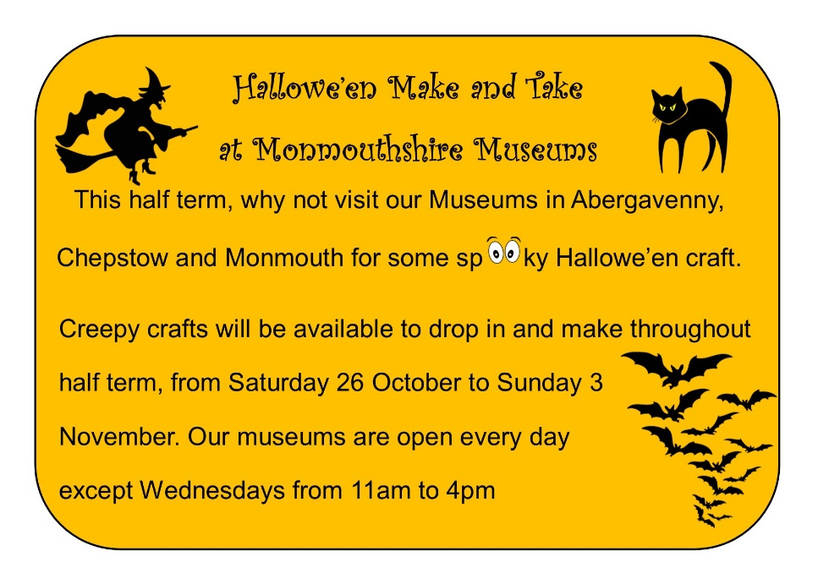

**The Battle of Trafalgar in miniature!**

**At Monmouth Museum, Tuesday 29th October 11am – 4pm**

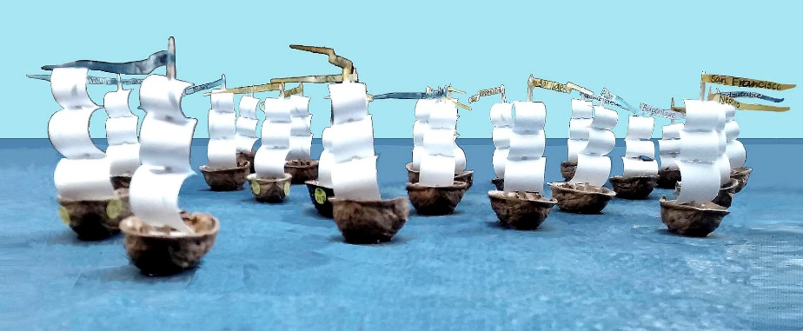

**The Battle of Trafalgar is coming to Monmouth!**

On the 29th of October, this historic event will be demonstrated at the Nelson Museum, all day from 11.00am to 4.00pm, using fleets of battle-ready model ships and a slide-show of background information

Nelson, in the person of former Royal Marine and actor Sebastian Bowen, will be there to describe the action and answer questions on any related subject; discover the stories of the individual vessels and their captains, why limes and the matchlock firing mechanism were crucial and what was special about Nelson’s hat.

The 76 model ships are only made out of walnut shells, but they create a fine picture of the principle of Nelson’s attack against the combined French and Spanish fleet.

We hope people will drop in during the day to see what’s going on and pick up the action.

**Chepstow Museum’s DROP-IN-AND-MAKE Half Term Craft Session**

**At The Drill Hall, Lower Church Street, Chepstow - Thursday 31st October 2-4pm**

Chepstow Museum is running its popular drop in craft afternoon during the half term holidays on Thursday 31st October from 2 until 4pm at the Drill Hall in Lower Church Street.  We’ll be making things with a suitably spooky and seasonal theme, with Hallowe’en that night and Fireworks night coming up! We supply some templates, ideas and materials you bring your creativity to make something special of your own. We’ve got big tables so you can meet up with friends or bring family and have fun making things together.

Suitable for children of all ages, all children must be accompanied by an adult – up to three children per adult. Come for the whole afternoon or just pop in for a short time. Donations towards the cost of materials and refreshments are always welcome, we suggest £2 for children aged 3+

We look forward to seeing you there!