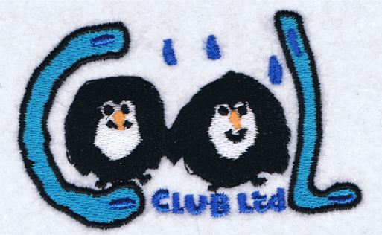

Welcome
Pack

COOL CLUB INFORMATION SHEET
TO BE RETAINED FOR INFORMATION

Session Timings & Prices

Breakfast | 7:30-8:45 | £5.60
After School (Full) | 3:15-6:00 | £8.50
After School (Half) | 3:15-4:30 | £5.60

Penalty Charges: £10.00 for up to each 15 minute period after 18.00 hours.
Outstanding Fees: £10 will be added to next bill if previous bill is not paid within 14 days of receipt.

All Enquiries and Bookings: Ring – Cool club Mobile: 07763479119
Email: coolclub.chepstow@gmail.com

If your child will not be attending a session because of illness or other reason please ring and let us know. Similarly if you collect your child from school and they are booked in to Cool Club please advise the staff that you have collected your child.

Cancellation: We require 2 weeks’ notice if you wish to cancel your child’s place.
All other absences will be charged at full rate.

Your Child’s safety is very important to us so please follow the rules below:

Other People collecting your child: If anyone other than the persons listed on your registration form is picking up your child we will need a written note from you (e.g. your child is going to a friend‘s and another child’s mother will pick up). If this is a last minute arrangement please make sure that you ring the play manager otherwise we will be unable to release your child into their care. If the person you have agreed to pick up your child is unknown to us we will ask them and your child to tell us the agreed password before allowing them to leave with that individual.
Children’s possessions: Please do not send your children to Cool club with mobile phones or expensive gaming equipment or MP3 players/ipods as we cannot be held responsible for any loss or damages.
Temporary Medication: For any child that requires temporary medication please forward a letter of authorization detailing clear instruction about the medication to be given (i.e. dose and frequency).
A permanent record of this information will be recorded on the Medication Form.

PLEASE INFORM US IMMEDIATELY OF ANY CHANGE IN CONTACT DETAILS, ADDRESSES, EMAIL AND TELEPHONE NUMBERS.

A copy of Cool Club policies & procedures (including complaints, behaviour and safeguarding) are available to view at the front desk in the hall. Complaints & behaviour policies are also on our notice board. New parents will receive, via email, a link to our online drive which is where our policies are also available to view.

COOL CLUB LTD REGISTRATION & MEDICAL CONSENT FORM
CHILD DETAILS
Name
Date of Birth
Address
Tel No:
PARENT/PERSON WITH PARENTAL RESPONSIBIBLITY DETAILS
Name
Address (if different from above)
Tel No (Home)
Tel No (Work)
Mobile
E-mail
GP AND MEDICAL DETAILS
GP Name
Address
Tel No
Last Tetanus
Medication Details
Known Allergies (to include food)
EMERGENCY CONTACT/PERSONS AUTHORISED TO COLLECT CHILD
(who will be contacted to collect child if parent is unavailable/unable to by 17.55 PM or in minor emergency )
Name |  | Name
Relationship to child |  | Relationship to child
Tel No |  | Tel No
Any other Information such as special dietary requirements
(continue on separate sheet if needed)

I consent to any emergency treatment necessary during the running of the club and conveyance to hospital if necessary. I authorise the play/care staff to sign any written form of consent required by the hospital authorities if delay in getting my signature is considered by the doctor to endanger my child’s health and safety. I also authorise the use of the following on my child if needed: anti-sting products, plasters, dry dressings.
I agree to collect my child at 6:00PM. If this is not possible for some emergency reason I will telephone the Cool Club Manager in advance and arrange for someone to collect my child for me. I also accept that my child will not be covered by any insurance after 18.00 hours and I agree to pay the penalty charges as set out on the attached sheet.

Signed______________________________Print Name________________________________
Date________________________________

For any child with a serious illness e.g. asthma/ allergies
We require clear written instructions about the condition i.e. symptoms of condition, what triggers the condition, what to do if symptoms get worse etc.
If you require any medication to be administered by staff you must give your authorisation below together with clear instruction about the medication, i.e. dosage, when it has to be taken etc.
Child’s Name___________________________________________________________________
Condition ______________________________________________________________________
I hereby authorise Cool Club staff to administer medication to my child
______________________________________________________________________________

Signed_________________________Print Name_________________________Date________
NB If not signed by the birth mother we will need proof that signatory has parental responsibility e.g. marriage certificate, adoption papers, birth certificate.

Parent/Carer’s Contract

Child’s name

Parent or carer’s name

- I consent for my child to attend Cool Club. I understand that the club has policies and procedures (which are available for reference at the club), and that there are expectations and obligations relating both to the club and to myself and my child, and I agree to abide by them.
- I understand that Cool Club is a play setting and that whilst my child is there Cool Club is legally responsible for him/her.
- My child will be provided with a snack and drink whilst at the club unless otherwise requested.
- Once my child arrives at Cool Club he/she will be in the care of Cool Club until collected and signed out by an authorised person.
- I will notify the club before the start of the session if I am collecting my child from school on a day that he/she is booked to attend the club. I understand that I will be charged for the booked session.
- I will book my child into the club on a monthly basis and will pay promptly for all booked sessions whether my child attends or not (e.g. due to illness or holidays).
- It is my responsibility to keep the club manager informed of any alterations to the information regarding my child (e.g. contact details, medical conditions, etc.).
- I accept that my child may take part in messy activities while at Cool Club. I understand that I can provide my child with appropriate clothing to accommodate this if I wish.
- Cool Club closes at 6:00pm. If, due to unforeseen circumstances, I am going to be late, I will contact the manager/deputy as soon as possible.
- If I do not collect my child by 6:00 pm I will pay a charge of £10.00 per quarter of an hour to cover the costs of the two staff who are legally required to supervise my child.
- If I do not collect my child by 6.30pm, and the club has been unable to reach me on any of my emergency contacts, I understand that Cool Club will follow its Uncollected Children Policy and contact Social Care.
- Whilst Cool Club tries to ensure the safety and security of items, I understand that it cannot be held responsible for loss or damage to my child’s property.
- I have read the club’s Behaviour Management Policy and agree to its terms and appreciate that in some circumstances it may be necessary to exclude my child from the club, and I will pay for any missed sessions unless otherwise agreed with the manager.
- If there are any accidents or incidents at Cool Club involving my child, I will be informed.
- If my child has an accident at the club, he/she will be treated by a qualified first aider and I will be informed as soon as possible. If my child needs urgent medical treatment and I am unavailable, a member of staff from Cool Club will sign any consent forms necessary for treatment on my behalf, as stated on the club’s Medical Form.
- Information held by Cool Club regarding my child will be treated as confidential. However, in certain circumstances, for example if there are child protection concerns, I understand that the club has a legal duty to pass certain information on to other agencies, including Police, Social Care and health care professionals.
- I understand that aggressive and abusive behaviour towards staff will not be tolerated.

I have read and understood the above terms and conditions and I agree to abide by them.
Signature:

Date:

Photograph Permission Form
The use of photographs is an important developmental tool which is widely used in play and educational settings for recording, sharing and displaying activities that your children have undertaken. At Cool Club we take the issue of child protection very seriously and we would never knowingly publish an image of your child without your consent.
________________________________________________________________________
As the parent or carer of the child named below, I grant permission for images of my son or daughter to be used for the following purposes:

(Please tick for consent)
- Electronic and printed information, displays and exhibitions at the Club
- Website for Club
- Promotional material for the Club
- To accompany staff or student coursework
- Observation and assessment
- Club records of my child
- Local newspaper or magazine
- National newspaper or magazine
- Other organisation’s website
- Other organisation’s promotional material
- Other

I understand that personal details or names of any child in a photograph will never be given in such a way that would allow them to be individually identified.
I understand that this image will NOT be used for anything which may be viewed as negative in tone or that may cause offence, embarrassment or distress for the child or their parent or carer.
I understand that there will be no payment for my child’s participation.

Child’s name:

Signed: Date:
(Parent/carer)

Print name:

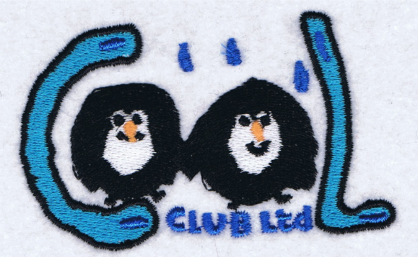
COOL CLUB LTD

Please confirm and sign the following sessions that you require.
If you do not require regular sessions and will be using the club on an ad-hoc basis, please leave blank.
CHILD NAME:
Sessions
 | Monday | Tuesday | Wednesday | Thursday | Friday
AM
4:30PM Collect
6:00PM Collect

*Ad-Hoc sessions will be billed a month behind.

Signed Parent:
Date:

Safeguarding
Your Child’s safety is very important to us so please follow the rules below:
Breakfast | 7:30-8:45 | £5.60
After School (Full) | 3:15-6:00 | £8.50
After School (Half) | 3:15-4:30 | £5.60

Please can all Cool club parent/carers speak to us, txt or email us so we know your child
- Is going home straight from school with you
- Is going home with someone else
- Is not attending Cool club when they are booked in
Mobile Txt: 07763479119

All About Me…
My name is
I am years old. I was born on:

My favourite toys
are:

Things I would enjoy doing at Cool Club:

Cool Club
Ltd

I may need help with:

I am very clever at:

I like to eat and drink:

I can do these things by myself:

At Home, I like to:

My favourite books/
stories are:

